

|  |
| --- |
| **MATHEMATICS DEPARTMENT 2015**  **Year 11 Specialist - Test Number 1 – Basic Vectors Resource Free Section** |

**Name: _______SOLUTIONS_____________________ Teacher: __________________**

**Marks: 30**

**Time Allowed: 25 minutes**

**Instructions:** You **ARE** **NOT** permitted any notes or calculator.

_________________________________________________________________________

1 Which of the following best describes the direction of the position vector of P(4, −5)?

A 51°

B 219°

C −25°

D 309°

E 129°

[1 mark]

2 Calculate the resultant of the forces shown below.



A 21 N to the left

B 123 N

C 37 N to the right

D 21 N to the right

E 65 N to the left

[1 mark]

3 This diagram shows vectors m, n and a third vector.   
Which of the following best describes the third vector?

A m + n

B −n + m

C n + m

D m − n

E n − m

[1 mark]

4 If a = −2i + 7j, which of the following vectors is opposite in direction to a?

A (−2, −7)

B 

C 5i − 10j

D (6, −21)

E −7i + 2j

[1 mark]

5 This diagram shows vectors p and q.   
Which of the following best represents the   
resultant of p and q? (circle one)



[1 mark]

6 Which of the following is perpendicular to a = (0, −7)?

A i + j

B (−3, 1)

C −7i + j

D (−1, 1)

E −4i

[1 mark]

**End of Multiple Choice Questions**

7 Write the following vectors in polar form.

a A vector q with norm 6 in the positive direction of the y-axis $\left(6,90°\right)$

b A vector v of magnitude 8 in a direction 45° clockwise from the x-axis $(8,315°)$

[2 marks]

8 Convert the following vectors to component form.

a (8, 60°)



$(8\cos{60°},8\sin{60°})$

$=(8×\frac{1}{2}, 8×\frac{\sqrt{3}}{2})$

$=(4, 4\sqrt{3})$

b (5, 210°)



$(5\cos{210°},5\sin{210°})$

$=(-5\cos{30°},-5\sin{30°})$

$=(-5×\frac{\sqrt{3}}{2}, -5×\frac{1}{2})$

$=(-\frac{5\sqrt{3}}{2},-\frac{5}{2})$

[4 marks]



9 Convert the following vectors to polar form.

a (3,−3)

magnitude = $\sqrt{3^{2}+3^{2}}=\sqrt{2×9}=3\sqrt{2}$

reference angle = $45°$ but in Q4 so $315°$

$(3\sqrt{2}, 315°$)



b ($-\sqrt{3}$, 1)

magnitude = $\sqrt{3+1}=\sqrt{4}=2$

reference angle = $\tan^{-1}\left(\frac{1}{\sqrt{3}}\right)=30$ but in Q2 so $150°$

$(2, 150°$)



[4 marks]

10 Find the norm of each of the following vectors.

a (−2, 7)

$norm=\sqrt{4+49}=\sqrt{53}$

b 

Pythagorean Triple: 10, 24, 26

$∴norm is$ 26

[2 marks]

11 Given d = (8, −2) and e = (−4, −2), find:

4(2d − 3e)



$=4\left(2\left(\begin{matrix}8 \\ -2\end{matrix}\right)-3\left(\begin{matrix}-4 \\ -2\end{matrix}\right)\right)$

$=4\left(\left(\begin{matrix}16 \\ -4\end{matrix}\right)-\left(\begin{matrix}-12 \\ -6\end{matrix}\right)\right)$

$=4\left(\begin{matrix}28 \\ 2\end{matrix}\right)$

$=\left(\begin{matrix}112 \\ 8\end{matrix}\right)$

[2 marks]

12 Write the following vector as a linear combinations i and j.

a m = (2,−5)

$2i-5j$

[1 mark]

13 Find the value of α and β given that **m** and **n** are non-parallel vectors and the following is true:

(α-β+1)**m**=(β-3)**n**

α-β+1=0 and β-3=0



α-3+1=0 β=3



α=2



[3 marks]



14 Given $a$ = (5, 20 $°$) state $\hat{a}$.

$(1,20°)$

[1 mark]

15 OABC is a trapezium with OC parallel to, and twice as long as, AB. D is the mid-point of BC.

If $\vec{OA}=\tilde{a}$ and $\vec{AB}=\tilde{b}$, express each of the following in terms of $\tilde{a}$ and/or $\tilde{b}.$



$\vec{BC}=-\tilde{b}-\tilde{a}+2\tilde{b}=\tilde{b}-\tilde{a}$

$\vec{OD}=\vec{OA}+\vec{AB}+\vec{BD}$

$=\tilde{a}+\tilde{b}+\frac{1}{2}(\tilde{b}-\tilde{a})$

$=\tilde{a}+\tilde{b}+\frac{1}{2}\tilde{b}-\frac{1}{2}\tilde{a}$

$∴\vec{OD}=\frac{\tilde{a}}{2}+\frac{3\tilde{b}}{2}$

[5 marks]



|  |
| --- |
| **MATHEMATICS DEPARTMENT 2015**  **Year 11 Specialist - Test Number 1 – Basic Vectors Resource Rich Section** |



**Name: ______SOLUTIONS____________________ Teacher: __________________**

**Marks: 20**

**Time Allowed: 20 minutes**

**Instructions:** You **ARE** allowed 1 page of notes (both sides) and a CAS calculator.  
  
***You must show your working to receive full marks whenever a question is worth more than 2 marks.***

_________________________________________________________________________

16 Given f = (20, 46°), g = (18, 144°) find f + g by first changing to component form. Give your answer in polar form to the nearest whole number.



$\left(\begin{matrix}13.89… \\ 14.386…\end{matrix}\right)+\left(\begin{matrix}-14.56… \\ 10.580…\end{matrix}\right)=\left(\begin{matrix}-0.669… \\ 24.9669….\end{matrix}\right)≈\left(\begin{matrix}25 \\ 92°\end{matrix}\right)$

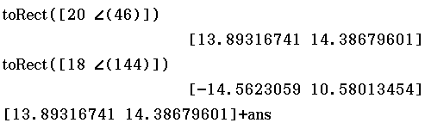

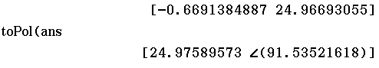

[3 marks]

17 Find the displacement vector for the following movement.

A(3, 4) to B(5, −3)

(5,-3) – (3,4) = (2,-7)

[1 mark]

18 Use a parallelogram of vectors to demonstrate that addition of geometric vectors is commutative.





Vector addition is commutative because the diagram shows a + b = b + a.



[2 marks]

19 State a vector parallel to $\left(\begin{matrix}3 \\ 2\end{matrix}\right)$ with a magnitude the same as the vector $\left(\begin{matrix}3 \\ -4\end{matrix}\right)$. Leave your answer in exact form.



$\left|\left(\begin{matrix}3 \\ 2\end{matrix}\right)\right|=\sqrt{13}$ $∴Unit vector is \left(\frac{3}{\sqrt{13}},\frac{2}{\sqrt{13}}\right)=\left(\frac{3\sqrt{13}}{13},\frac{2\sqrt{13}}{13}\right)$

$\left|\left(\begin{matrix}3 \\ -4\end{matrix}\right)\right|=5$ $∴Vector is \left(\frac{15\sqrt{13}}{13},\frac{10\sqrt{13}}{13}\right)$

[3 marks]

20 Given x = (27, 216°) and y = (22, 342°), find x + y without changing to component form. (to 1 d.p.)

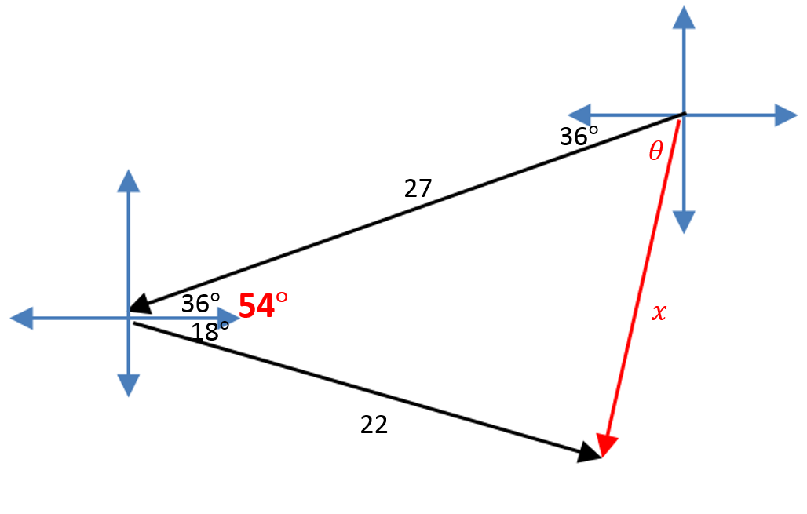



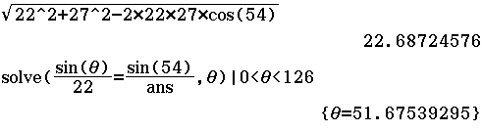



$∴Polar angle is 216+51.67…=267.67…°$

$x+y=(22.7, 267.7°$)

[5 marks]

21 A car travelling at 12 m/s at a bearing of 293° changes to 15 m/s at a bearing of 015°. What is the change   
in velocity? (to 1.d.p.)

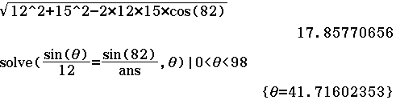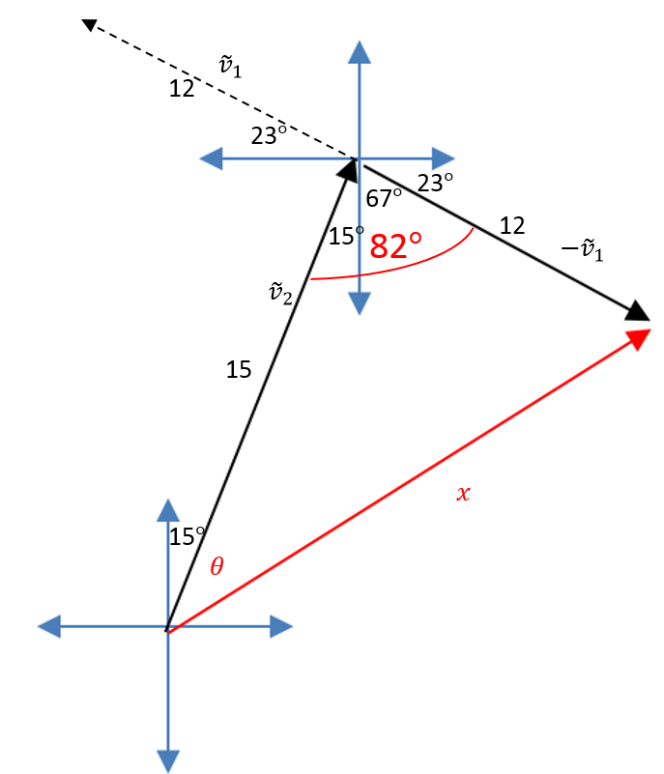



$$∴Bearing is 15+41.716…=56.716…°$$

$∴Change in velocity is 17.9m/s$ $on bearing of 56.7°.$

Alternate Working:



${\tilde{v}}_{1}=\left(\begin{matrix}12 \\ 157°\end{matrix}\right), {\tilde{v}}_{2}=\left(\begin{matrix}15 \\ 75°\end{matrix}\right)$

$∴{\tilde{v}}_{2}-{\tilde{v}}_{1}=\left(\begin{matrix}3.88… \\ 14.48…\end{matrix}\right)-\left(\begin{matrix}-11.046… \\ 4.67…\end{matrix}\right)=\left(\begin{matrix}14.928… \\ 9.800…\end{matrix}\right)$

$∴{\tilde{v}}_{2}-{\tilde{v}}_{1}=\left(\begin{matrix}17.9 \\ 33.3°\end{matrix}\right)$

$∴Change in velocity is 17.9m/s$ $on bearing of 56.7°$

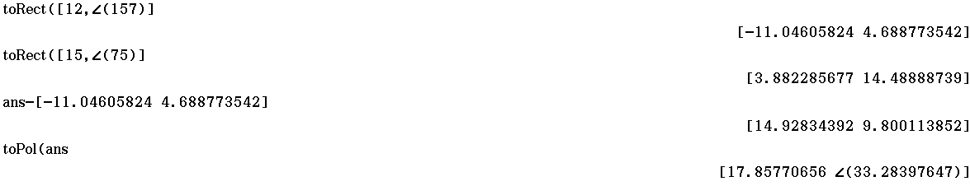

[6 marks]